AI-Driven Data-Driven Decision Support System (DDSS) for Intelligent Waste Collection

Author: Adeel Ahmed
Project Type: AI-Enabled Smart Waste Management Platform
Purpose: Academic Research / Intelligent Urban Infrastructure System
1. Introduction
Municipal solid waste management has become an increasingly complex challenge for modern cities. Rapid urbanisation, population growth, and increased consumption patterns have significantly increased the volume of waste produced in urban environments. Traditional waste collection systems typically rely on static collection schedules and predetermined vehicle routes. Under this approach, waste collection trucks visit bins at fixed intervals regardless of their actual fill level or urgency.
Although this method has been used for decades, it creates several operational inefficiencies. Bins may be collected when they are only partially full, leading to unnecessary collection trips and inefficient fuel usage. At the same time, other bins may reach critical capacity levels before the next scheduled collection time, resulting in overflow, environmental pollution, and public dissatisfaction.
These inefficiencies increase operational costs for municipalities while simultaneously contributing to higher greenhouse gas emissions and increased traffic congestion. As cities continue to grow, traditional reactive waste management approaches become increasingly unsustainable.
Recent advances in Artificial Intelligence (AI), Machine Learning (ML), and Internet of Things (IoT) technologies provide an opportunity to transform waste management systems into intelligent and data-driven infrastructures. Smart bins equipped with sensors can monitor waste levels in real time, while AI algorithms can analyse data and generate optimized collection strategies.
This project proposes and implements a Data-Driven Decision Support System (DDSS) designed to improve waste collection efficiency by integrating multiple AI technologies into a unified operational platform. The system combines computer vision for waste classification, predictive analytics for bin fill forecasting, multi-factor decision scoring, and vehicle routing optimisation. By converting data into actionable insights, the system enables municipalities to make smarter waste collection decisions.
The goal of this research is to demonstrate how integrating artificial intelligence models with operational logistics systems can significantly improve municipal waste collection efficiency.

2. Problem Statement and Objectives
2.1 Problem Statement
Traditional waste collection systems operate using fixed schedules and static routes. While simple to implement, this approach suffers from several major limitations.
First, waste collection trucks often visit bins that are only partially filled. This results in inefficient vehicle utilisation and unnecessary operational costs. Fuel consumption increases, collection time rises, and the system wastes resources.
Second, some bins may reach capacity earlier than expected due to increased local waste generation. Because the system does not monitor bin fill levels dynamically, these bins may overflow before the next scheduled collection.
Third, collection routes are typically planned based on geographical areas rather than real-time demand. Vehicles may travel inefficient routes, increasing travel distance and fuel consumption.
Fourth, traditional systems lack predictive capabilities. They react to current bin states rather than forecasting future waste accumulation. This reactive behaviour makes it difficult to prevent overflow or anticipate service requirements.
Finally, many existing waste management platforms do not integrate artificial intelligence with operational decision-making. Machine learning models may be used for research experiments, but they are rarely connected directly to real-world collection planning systems.
These limitations highlight the need for an intelligent waste management system capable of analysing real-time data, predicting future conditions, and generating optimized operational decisions.

2.2 Project Objectives
The primary objective of this project is to design and implement an intelligent waste management platform that integrates artificial intelligence with operational logistics.
The key goals of the project include:
- Developing an AI-based waste classification model using deep learning
- Implementing a predictive model for forecasting bin fill levels
- Designing a priority scoring system for waste collection decision-making
- Creating a routing optimisation algorithm for efficient collection routes
- Building a backend system to manage waste infrastructure data
- Developing a web-based dashboard for operational monitoring and management
- Integrating all components into a unified Data-Driven Decision Support System
By achieving these objectives, the project aims to demonstrate how AI-driven systems can support intelligent urban infrastructure.

3. System Overview
3.1 Platform Components
The proposed system is an integrated platform composed of multiple components working together to support intelligent waste management decisions.
The system architecture consists of three primary layers:
- Artificial Intelligence Layer
- Backend System Layer
- Frontend Dashboard Layer
Each layer performs specific tasks and communicates with the others through structured APIs.
The AI layer processes data and generates predictions. The backend system stores and manages data while executing decision algorithms. The frontend dashboard provides a user interface that allows organisations to monitor operations and interact with the system.
Together, these components form a complete decision support platform.

3.2. Platform Architecture
The developed system is composed of two major software components: a public informational website and an operational enterprise dashboard used by waste management organisations.
The public website presents the concept of the smart waste management system, describing the benefits of AI-based waste management and providing an overview of the platform. This website acts as an entry point for organisations interested in adopting the system.
The enterprise dashboard is the operational control centre of the system. It allows organisations to manage waste infrastructure, monitor bin data, run decision support algorithms, and analyse operational performance.
The platform architecture consists of the following components:
• Frontend Web Dashboard
• Backend API Server
• AI Decision Models
• Database System
• Decision Support Engine
These components communicate through REST APIs to ensure modular system design and scalability.

Figure 1: Smart Waste Platform Architecture
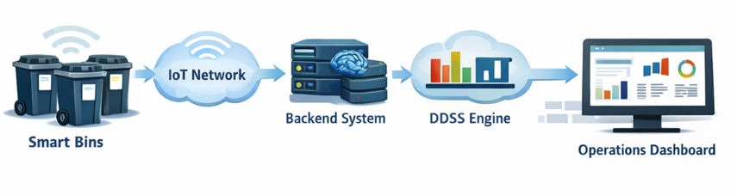

4. Enterprise Infrastructure Model
4.1. Enterprise Infrastructure Model
The system models waste management infrastructure using a hierarchical enterprise structure designed to represent real municipal waste collection systems.
The hierarchy consists of the following levels:
- Owner
- Admin
- Organisation
- Site
- Zone
- Bin
Each organisation represents a municipal authority or waste management company responsible for managing waste collection within a geographic area.
Within each organisation, waste collection areas are divided into Sites, which typically represent districts or administrative regions of a city.
Each site is further subdivided into Zones, which represent smaller operational sectors such as residential areas, commercial districts, or transport hubs.
At the lowest level of the hierarchy are Bins, which represent individual waste containers deployed throughout the city.
Each bin stores operational information including:
- Bin ID
- Geographic coordinates
- Site location
- Zone location
- Postcode
- Sector
- Fill level
This hierarchical model enables the system to organise waste infrastructure across multiple cities and regions.
Figure 2: Enterprise Hierarchy Structure
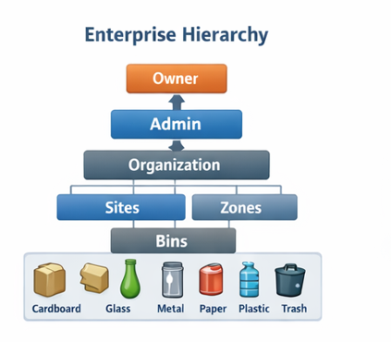

4.2. Enterprise Management Model
The platform is designed to support municipal waste management systems that operate across multiple geographic areas and organisations.
To achieve this, the system implements a hierarchical enterprise structure consisting of several administrative levels.
At the highest level is the Owner, who manages the entire platform and controls system-level configuration. Owners can create organisations and assign administrators.
Below the owner is the Admin role, responsible for managing organisational infrastructure such as sites, zones, and users.
Each organisation represents a municipal authority or waste management company. Within an organisation, waste collection areas are divided into Sites representing geographic regions or districts.
Each site is further divided into Zones, representing smaller operational areas such as neighbourhoods or service sectors.
Within each zone, individual Bins are deployed. These bins represent smart waste containers that generate data for the system.
This hierarchical structure allows waste management operations to scale across cities and regions.

4.3. User Roles and Permissions
The system implements a role-based access control model to ensure that users can only access functions relevant to their responsibilities.
The Owner role has the highest level of access and is responsible for managing the overall system. Owners can create organisations, manage administrators, and monitor system-wide analytics.
The Admin role manages operational infrastructure within organisations. Administrators can create sites, zones, and bins, manage users, and run system analysis tools.
The Manager role oversees waste operations within a specific organisation. Managers can monitor bin status, run decision support algorithms, and manage local operational activities.
The Operator role represents field personnel responsible for waste collection activities. Operators can view assigned bins, access route plans, update bin status, and report operational issues.
Finally, the Viewer role provides read-only access to dashboards and analytics for monitoring purposes.
This structured role hierarchy ensures secure and organised system operations.

5. Backend System Architecture
5.1. Backend System and API Infrastructure
The backend system is responsible for managing all operational data and coordinating communication between the dashboard interface and AI decision modules.
The backend is implemented using a REST-based API architecture. The system stores all operational data in a central database, including organisations, sites, zones, bins, telemetry data, and system logs.
Key backend functionalities include:
- User authentication and role management
- Organisation and infrastructure management
- Bin registry management
- Telemetry data processing
- Decision support system execution
- Vehicle routing optimization
- Alert generation and monitoring
The backend system exposes multiple API endpoints that allow the frontend dashboard to interact with the platform.
Examples of backend APIs include:
- POST /organisations
- POST /sites
- POST /zones
- POST /bins
- GET /telemetry
- POST /ddss/run
- POST /routing/run
These APIs enable the dashboard to dynamically manage infrastructure and trigger decision support processes.

Figure 3: Backend API Interaction with Dashboard
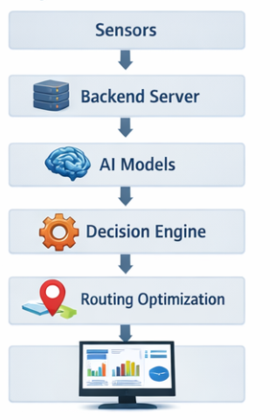
5.2. System Architecture
The system architecture is designed to support scalable waste management operations across multiple organisations and geographic locations.
The architecture begins with data collection from bins or simulated sensor data. This data includes bin fill levels, geographic locations, and timestamps. The data is transmitted to the backend system through APIs.
The backend system stores this information in a database and triggers machine learning models when necessary. AI models analyse the data to classify waste types and predict future fill levels.
The results of these models are passed to a decision engine that calculates priority scores for each bin. Based on these scores, the routing module generates optimized vehicle collection routes.
Finally, the results are displayed in the operational dashboard, allowing administrators and operators to monitor system performance.

6. Waste Infrastructure Management
6.1. Bin Registry and Smart Waste Infrastructure
The bin registry module manages the digital representation of waste bins deployed across the waste management network.
Each bin is associated with a specific organisation, site, and zone, allowing the system to track its location within the infrastructure hierarchy.
- Bin data includes:
- Bin identifier
- Bin name
- Geographic coordinates
- Postcode and sector
- Fill level
- Associated site and zone
The bin registry enables managers to monitor waste infrastructure across different locations and provides the foundation for telemetry monitoring and routing optimisation.
Figure 4: Bin Registry Dashboard Interface
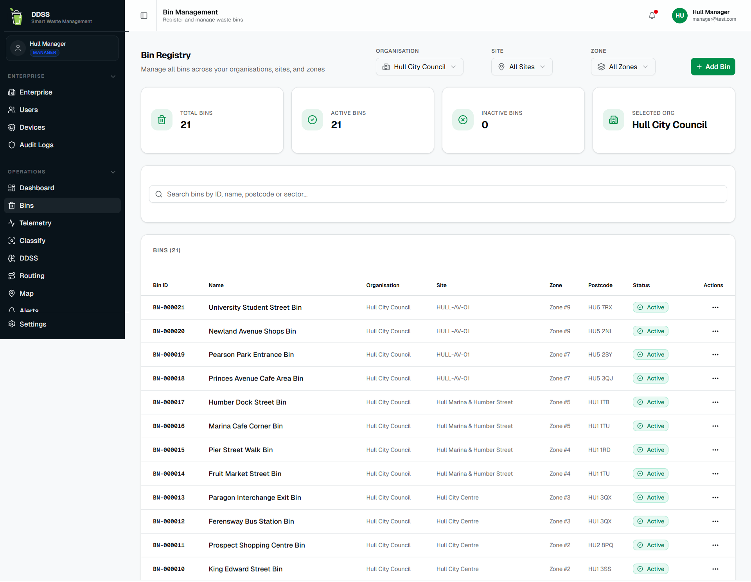
6.2. Telemetry Monitoring System
The telemetry system monitors bin fill levels and operational data across the waste network. Telemetry data represents the real-time or simulated sensor readings collected from smart bins.
Each telemetry record contains:
- Bin identifier
- Timestamp
- Fill level percentage
Telemetry data is visualised within the dashboard, allowing operators to monitor bin status across different sites and zones.
The telemetry system also provides the input data used by the forecasting model to predict future bin fill levels.
Figure 5: Telemetry Monitoring Dashboard
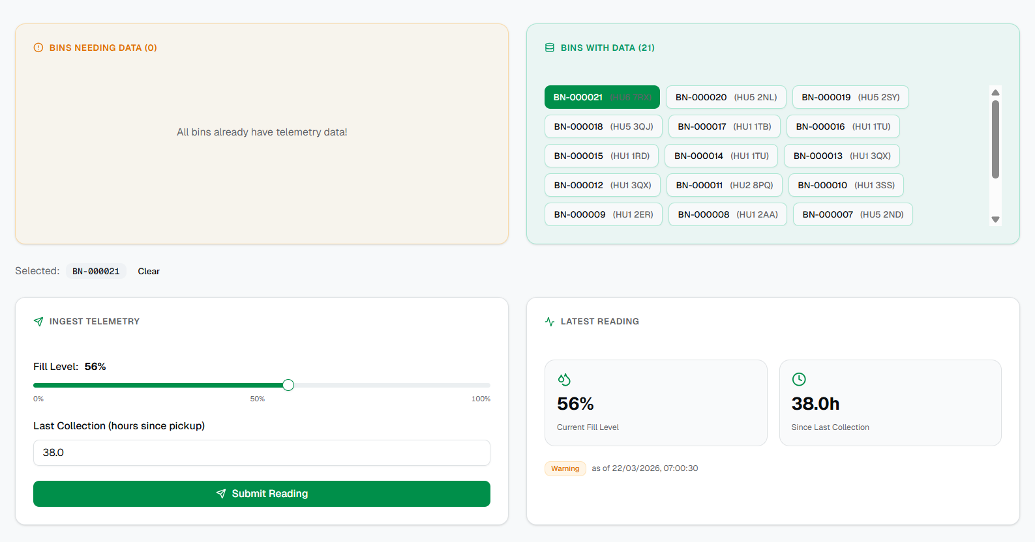

7. Data-Driven Decision Support System (DDSS)
The Data Driven Decision Support System (DDSS) forms the core intelligence of the platform. The DDSS integrates predictions from AI models with operational decision algorithms to generate optimized waste collection strategies.
The DDSS system processes several types of data:
• Bin fill level telemetry
• Forecasted waste accumulation
• Time since last collection
• Geographic bin locations
Using this information, the DDSS calculates priority scores for each bin and determines which bins require immediate collection.
The DDSS module allows managers to run the analysis through the dashboard interface, generating ranked lists of bins that require collection.
Figure 6: DDSS Decision Pipeline
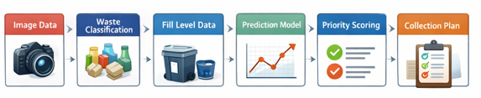

8. AI Models and Predictive Analytics
8.1. Waste Classification Model
The waste classification component uses a deep learning model to identify waste categories from images.
The model is based on the DenseNet121 convolutional neural network architecture, which is widely used for image classification tasks due to its efficient feature reuse and strong gradient flow properties.
The model was trained using the TrashNet dataset, which contains approximately 2500 labelled images of waste materials. The dataset includes six classes: cardboard, glass, metal, paper, plastic, and general trash.
Because the dataset is relatively small, transfer learning was used to improve performance. The DenseNet121 model was initialised with ImageNet pretrained weights and then fine-tuned using the TrashNet dataset.
Training included image augmentation techniques such as rotation, flipping, and scaling to improve model generalisation.
After fine-tuning, the model achieved approximately 85% classification accuracy on the test dataset. This level of performance is sufficient for decision-support applications within the waste management system.
Figure 8: Waste Classification Interface
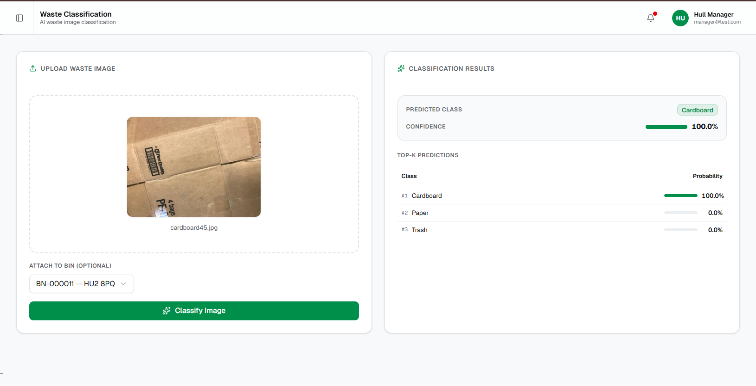

8.2. Fill Level Forecasting Model
In addition to classifying waste, the system predicts future bin fill levels using a machine learning regression model.
The forecasting model uses a Random Forest Regressor trained on simulated bin data representing waste accumulation patterns.
The model uses several features to predict future fill levels:
• Current bin fill level
• Hour of the day
• Day index
• Weekend indicator
The target variable is the predicted fill level several hours in the future.
The forecasting model achieved high predictive accuracy, with an R² score close to 0.98–0.99, indicating strong performance in predicting fill level growth patterns.
Predictive forecasting allows the system to anticipate when bins will reach critical capacity levels, enabling proactive collection planning.

Figure 9: Fill Level Forecasting Interface
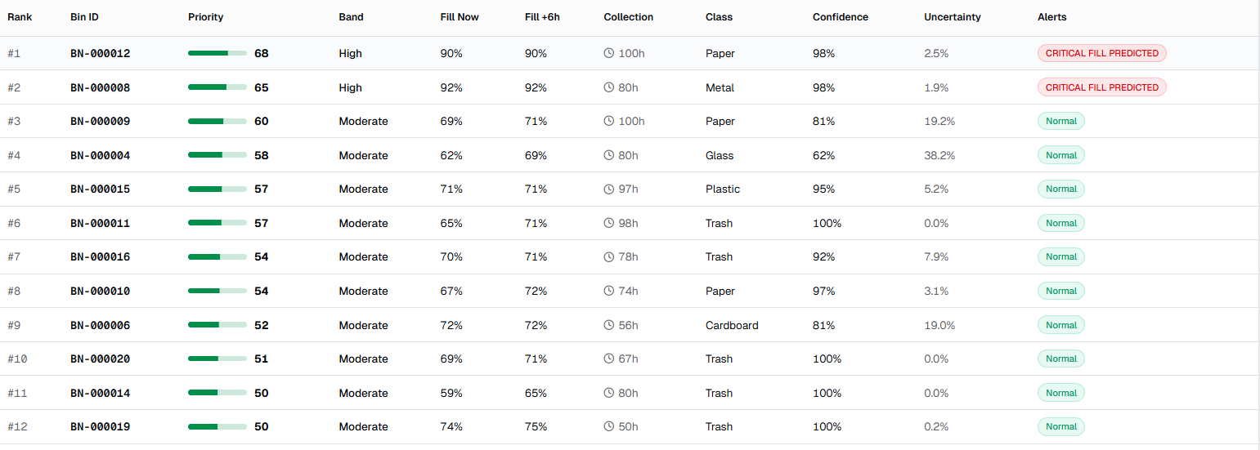

8.3. Priority Scoring System
To determine which bins should be collected first, the system uses a multi-factor priority scoring algorithm.
The priority score combines several factors that reflect the urgency of waste collection.
These factors include:
• Predicted bin fill level
• Time since last collection
• Model confidence
The scoring formula is designed so that bins with higher predicted fill levels and longer service delays receive higher priority scores.
In addition, prediction uncertainty is incorporated into the score to ensure that uncertain model predictions are treated cautiously.
This scoring mechanism transforms raw sensor and AI data into actionable operational priorities.

9. Routing Optimization System
After the DDSS prioritisation step identifies bins requiring collection, the routing optimisation module generates efficient collection routes for waste collection vehicles.
The routing system considers several factors:
• Geographic distance between bins
• Bin priority scores
• Vehicle capacity constraints
• Depot location
Distances between bins are calculated using the Haversine formula, which estimates great-circle distances based on geographic coordinates.
The routing algorithm generates an optimized route that minimises travel distance while ensuring high-priority bins are serviced first.
Figure 7: Routing Optimization Map
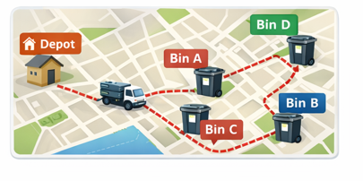
9.1. Vehicle Routing Optimization
Once bin priorities are calculated, the system generates optimized collection routes for waste collection vehicles.
Two routing strategies were tested during system development.
The first strategy was a priority-only approach in which bins were collected strictly based on urgency. However, this approach often produced inefficient travel paths because it ignored geographic distance.
The second strategy introduced a hybrid approach combining bin priority and geographic distance. The routing algorithm calculates the distance between locations using the Haversine formula, which accounts for Earth's curvature.
The system also incorporates vehicle capacity constraints to simulate real-world waste collection operations. When the total load of bins exceeds the truck capacity, the vehicle returns to the depot before continuing collection.
Experimental simulations demonstrated that the hybrid routing approach reduced travel distance by approximately 40% compared to priority-only routing strategies.

10. Dashboard and Operational Monitoring
The system includes a web-based dashboard that allows organisations to monitor waste collection operations.
The dashboard provides several modules including enterprise management, user management, bin registry, telemetry monitoring, routing visualisation, alerts, and analytics.
Users can interact with the dashboard to manage waste infrastructure, view operational data, and run AI-based analysis tools.
The dashboard is designed with role-based access controls so that users only see the features relevant to their role.
This interface allows organisations to monitor waste collection operations and make informed decisions using AI-generated insights.

11. Limitations and Future Work
Although the system demonstrates promising results, several limitations exist. The IoT sensor data used in the project is simulated rather than collected from real hardware devices. Future work should integrate real sensor hardware to validate system performance in real environments.
Additionally, routing calculations are based on geographic distances rather than actual road networks. Integrating GIS-based routing engines would further improve realism. Finally, the forecasting model uses synthetic historical data rather than real long-term waste generation data.
Several improvements can be implemented in future research. Real IoT smart bins could be deployed to collect real-time fill-level data. Traffic-aware routing algorithms could be implemented to account for road conditions and travel time variability.
Advanced machine learning models such as LSTM networks could be explored for long-term forecasting. A mobile application could also be developed to support waste collection operators in the field.

12. Conclusion
This project demonstrates the feasibility of an AI-driven Data-Driven Decision Support System for intelligent waste management.
By integrating waste classification, predictive analytics, priority scoring, and routing optimisation within a unified platform, the system transforms waste collection from a reactive process into an intelligent, data-driven operation.
Simulation results indicate that integrating predictive modelling with routing optimisation can significantly reduce travel distance and improve operational efficiency.
The proposed system represents a scalable framework for smart waste management and contributes to the development of intelligent urban infrastructure.

